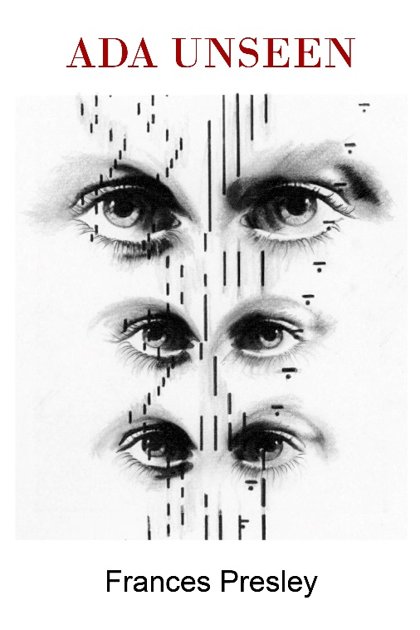
Ada Lovelace, daughter of Lord Byron, was a mathematician and computer visionary She wrote ‘Mathematical Science is the language of the unseen relations between things’, which is why my new book is called Ada Unseen. She lived on Exmoor and this landscape is reimagined through science and poetics, part of a collaboration with visual poet Tilla Brading, which will appear from Contraband press. Ada loved birds and a series of poems on birds and flight are designed like punch cards to isolate key words, creating an alternative text for a woman’s life. Various aspects of the ’unseen’ are explored including the human body, computing, music, the imaginary, and outer space. There is also an internet cut up and paste of ‘Ada’ and copious Notes. Ada Unseen, by Frances Presley. Shearsman, 2019. Paperback, 116pp, 9 x 6ins, £9.95 / $18 ISBN 9781848616639

It will be launched on Tuesday 12 March at 7.30 at Shearsman Readings, Swedenborg Hall, Swedenborg House, 20/21 Bloomsbury Way, London WC1 (nearest tube Holborn).
Admission free. www.shearsman.com

In Frances Presley’s new exhilarating and intellectually stimulating collection, the life and work of Ada Lovelace — innovator in the science of computing, but also lover of birds and music — is both focus and trigger. The concepts of the seen and the unseen in science, poetry and social mores permeate this volume, including contemporary society’s blindness to ecological destruction and the historical suppression of women. Creative tensions between the closed and open, the algorithmic and the intuitive, science and nature weave their way deftly through the book in a profusion of evocative and often witty allusions to birds, flight, landscape, architecture, computation and mathematics. Through ambiguous voices, shifts in time and location, quotation, word play, cut and paste, visual patterns and accompanying documentation, Presley gifts us a rousing, profound and multilayered poetic sequence.
Hazel Smith

Ada Lovelace provides the catalyst for this collection that juxtaposes the abstractions of science with the resistance of rural environments, particularly on Exmoor where ‘gorse is dense unfractured/ spike through every scrub leaf’. Alert to both the play of perception and the realities of climate change, the poems explore a world in which nothing is static: land slips. The effects of unseen codes that organise life, linking human and other existences, are glimpsed through the patterns of birdsong and algorithmic movement. As the poems unfold they reveal that numbers, too, have a life of their own. In her early contribution to the development of computers, Lovelace saw the potential for making music, and these poems listen acutely to the patterns of language and birdsong, rewilding language as sound and visual score. Encompassing a radical vision of history, landscape and contemporary politics, Frances Presley writes with wit, urgency and a commitment to experiment in its truest sense.
Zoe Skoulding

